Double Dummy Solver - DDS
http://RogerPf.com/aaBridge
Many thanks to Bo Haglund for writing the DDS – techies can google him.

The aaBridge DDS and Analyser are demonstrated in two aaBridge videos that you can find on YouTube.
Either use the YouTube link on the Welcome page of aaBridge
OR google YouTube aaBridge
once there play the two videos 004 Using the DDS and Analyser in aaBridge
008 Using 'Shuf Op' and the Analyser in aaBridge
What is a Double Dummy Solver
A double dummy solver (DDS) is a piece of software that can analyze a bridge deal and tell you, assuming both sides make the best plays they can, how many tricks each side can make. It can do this for all possible contracts played in all possible seats.
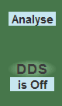
There are two ways to activate the aaBridge DDS. For your current contract, you would use the DDS button and for all possible contracts you use the Analyse button.
The online service, BBO, has a double dummy solver that will process only the current contract. It is activated with a click of their GIB button.
This type of software is called - Double Dummy - because it relies on being able to see all four hands and is equivalent to having two dummys.
Many thanks to Bo Haglund (techies can google him) who not only wrote this great DDS but has made the source available FREE for inclusion in software like aaBridge.
How does a DDS Help ?
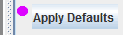
The best way to answer this question is to show an example.
Before you go to the example deal, as always, click the Apply Defaults button.
The example deal on the next page is taken from a set of deals in aaBridge.
It is the first deal in that first set of
menubar > Books-T > Boldbida 2016
Use Flow > until you can see the first deal and then click the Enter the Deal button.
The deal should look as shown on the right.
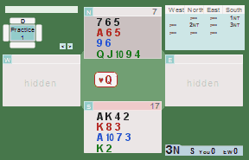
You are playing in 3 No Trumps.
The ♥Q has been led.
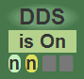
This beginner level problem has been selected as it is simple and demonstrates the DDS feature clearly.
Click the DDS is Off button so it says is On
The three hearts in the dummy will now be displayed with small numbers.
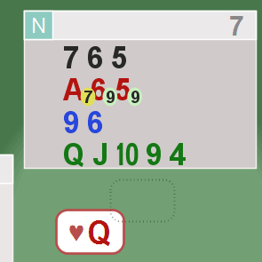
The two green ovals show you that the maximum number of tricks THAT SIDE can make is 9, which is what is required to make 3NT.
Any numbers in amber ovals show a poorer line of play. The numbers always refer to the SIDE they are on. You need to know ONLY the denomination (here NT) to make sense of the values.
The amber oval 7 says, play ♥A, and you only get 7 tricks.
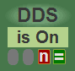
There is an alternative way to display these values.
You can switch from displaying 'amber oval's to displaying dark red and green squares. Click in the area below the is On message. (see above) . To return to seeing amber and green Ovals click the same place again
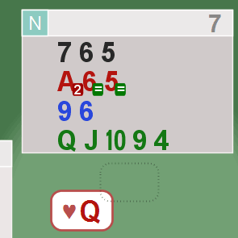
A white equal sign in a green box shows that DECLARER can make the contract if she/he plays this card.
A white number in a red box shows they will go down this number of tricks if that card is played.
White numbers in a green box (not shown) show the number of overtricks declarer can make.
Here, the numbers always refer to what the DECLARER can make.
You need to know both the denomination (here NT) and the contract level (here 3) to make sense of the values.
Click the Show button on the table to show the Non Kib seats.
Click the single arrow forward button > (if you use a mouse wheel you need only click it one time, after that the mouse wheel will remember the button you last pressed).
As you move through the play or after clicking edit, where you can elect to play all the cards yourself, you will see these digits against each card showing you the outcome if that card is played. All future plays are "best possible".
FYI - the aaBridge bots use the DDS when calculating their plays so they cannot make a mistake. But equally, they have a weakness. If they can see that there is a line whereby you CAN make the contract they have no idea which defence will be hardest.
When is the DDS most useful ?
The DDS numbers are most useful for finding hard to play card combinations such as squeezes and other end plays. For example, it is very useful when you review previously played hands that you have collected using the aaBridge Extract_MyHands_package
(from the doc collection).
You can easily use the DDS to quickly tell you why you made one less than could have made in a tricky ending hand.
A weakness of all DDSes is that they always know which finesses will work and which will not. In the same way they always know when they can drop singleton Kings and doubleton Queens. But these cases are all easy to see when you look at the hand, so you can discount them as things a human being can be expected to do.
The DDS will work also on partial deals (which have the same number of cards in every hand).

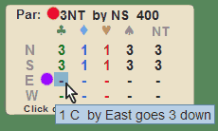
The Analyser
When you click on the Analyse button, the bidding panel is covered by the analyser panel. This shows a matrix of every possible denomination against the four compass directions. The numbers in the panel tell you what contract can be made. For example North can exactly make a contract of 1♥ heart.
If you hover over one of the hyphens you will see a tooltip message telling you how many down the contract of "1" will go. In this case, you can see the east will go three down if they try to play in 1♣. (purple dot)
The top line (red dot) shows the par contract, which is the highest score that can be made with perfect bidding and play from both sides.
Playing in a Contract
If you click on any of the hyphens or numbers, aaBridge will put you in that contract and go into play mode so you can play it.

The Message line
In the image above the tooltip is covering up a message line, you can just about see the word "Click". Here you will sometimes see information messages.
If all 52 cards have not been dealt then when you click the Analyse button you will see a message that reads.
52 cards ? Try Shuf Op first
The Shuf Op button
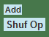
When you click the Shuf Op button, if any of the 52 cards have not been dealt then they are randomly assigned to hands that need them, and the analyser runs.
If any hand has more than 13 cards the analyser will not run.
If all four hands have 13 cards then the Opponents hands are shuffled, (hence the name of the button).
If the Opp's hands are set to be hidden, then at the end of the shuffle, aaBridge will assume you wish to play and put you into Play mode. If you are the declarer in the South seat it will lead the first card.
If the Opp's hands are set to show, then aaBridge will assume you do not want to play and that you just want to look at the hands.
This second option is most useful when you also have the analyser on. For example, if you are in a slam that has gone down, then when you put it into aaBridge (with the analyser on) and view all four hands, every time you press the Shuf Op button you get to see whether or not your slam will make with the newly dealt Opps cards.
This way you can get an idea if a hand was in a reasonable contract and you were just unlucky as to the layout of the opponents cards.

Controlling which cards are shuffled by Shuf Op
If you play a few tricks and then click on the Add button, then when you hit shuffle all the played cards will be exempt from the shuffle. The remove Rem button that will then be visible removes this restriction.
<end of document>

